Pfizer internal documents about covid vaccine trial
released under Federal Court order in USA
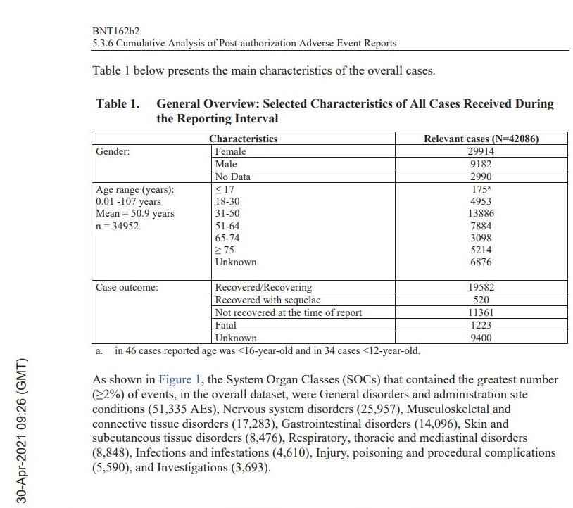

I calculated a death rate from their covid vaccine of 1,223 / 42,086 = 3%. The 9,400 unknown means the death rate is higher than 3%. So the death rate is greater than 3%. It could be as high as 5% or 6%. This is much higher than the death rate from covid19 virus.
I calculated a General Disorders rate for the covid vaccine of 51,335 / 42,086 = 121%. Some people got several disorders from the vaccine.
I calculated a Nervous Systems Disorders rate for the covid vaccine of 25,957 / 42,086 = 61%
I calculated injuries of 31,463 and an Injury Rate of 31,463 / 42,086 = 74% of which 36% had not recovered by the end of trial – 11,361 / 31,463 = 36%
I calculated a Musculoskeletal and connective tissues disorder rate of 17,283 / 42,086 = 41%
I calculated a Gastrointestinal disorders rate of 14,096 / 42,086 = 33%

I calculated a Skin disorders rate of 8,476 / 42,086 = 20%
I calculated a Respiratory disorders rate of 8,848 / 42,086 = 21%
I calculated an Infections and Infestations rate of 4,610 / 42,086 = 10%
I calculated an Injury, poisoning and procedural complications rate of 5,590 / 42,086 = 13%
I calculated an Injuries and Illnesses requiring further investigations rate of 3,693 / 42,086 = 8%

